1.

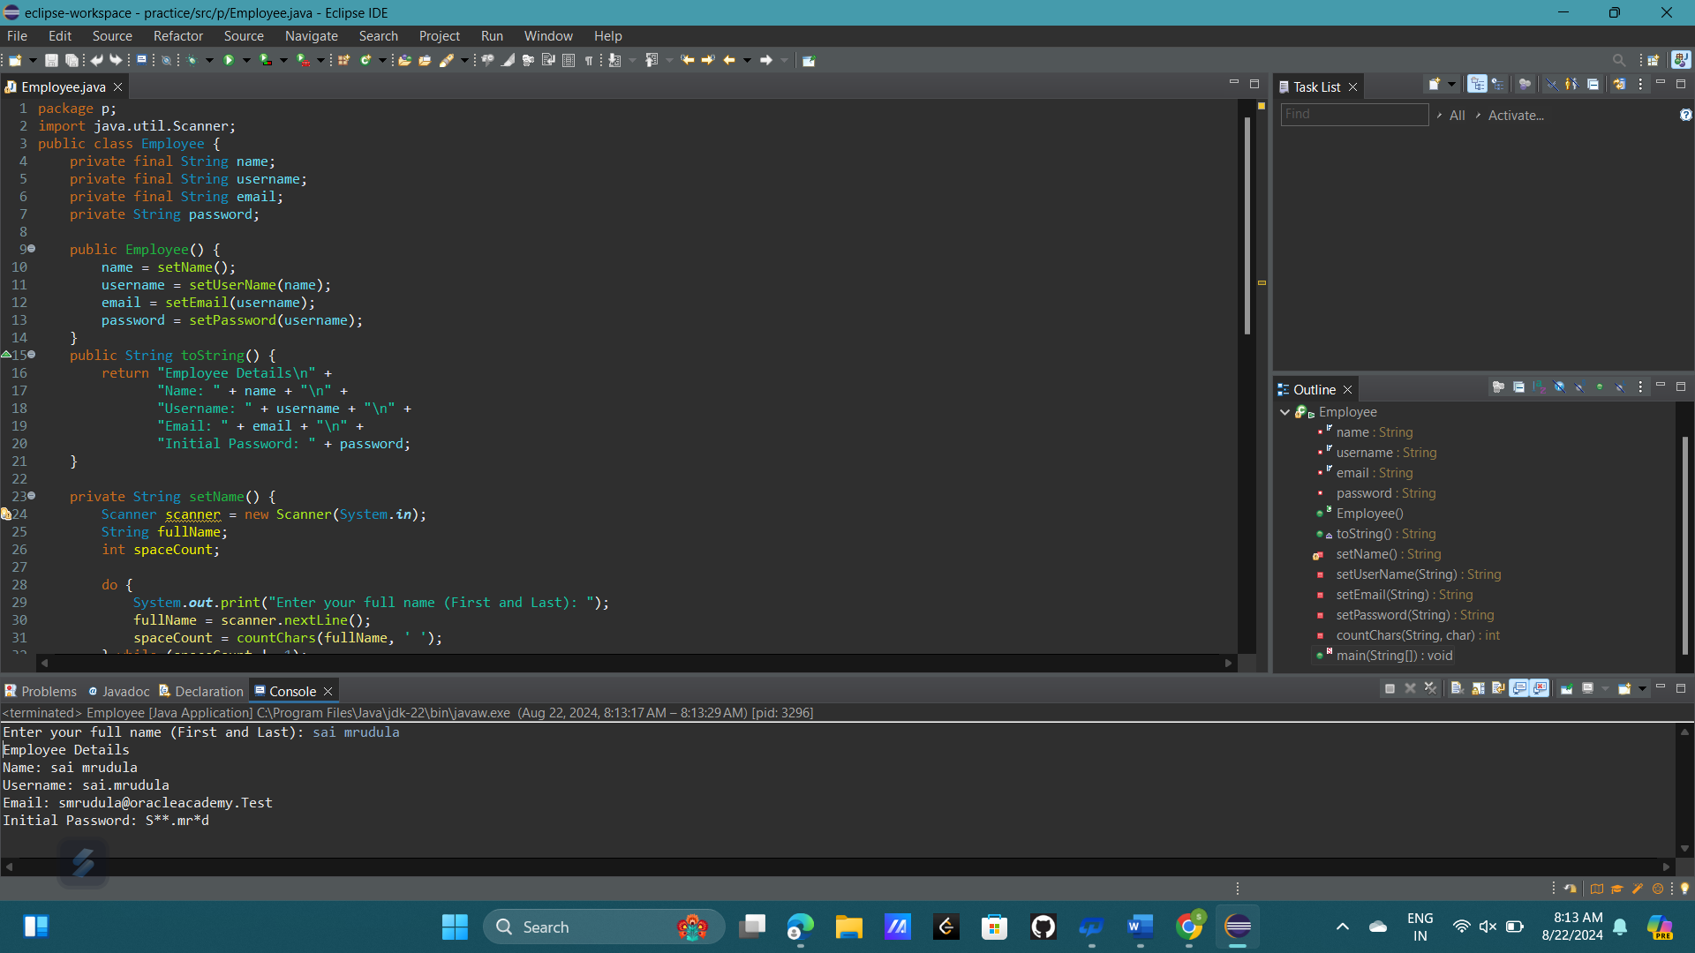

2.

public String reverse(String str) {

String strRev = "";

for(int i = str.length() - 1; i >= 0; i--) {

strRev += str.charAt(i);

}

return strRev;

}

3.

Yes, the reverse method will work for converting backward messages into forwards readable messages. The reason is that reversing a string is an involutory function, meaning if you apply the reverse operation twice, you get the original string back.

4.

The main difference is that String objects are immutable, meaning every modification creates a new string. In contrast, StringBuilder objects are mutable, allowing modifications in place, which is more efficient when performing repeated modifications.

5.

public class StringvsBuilder {

public static void main(String[] args) {

String str1 = "Hello";

StringBuilder str2 = new StringBuilder("Hello");

System.out.println(str1 + " " + str1.hashCode());

System.out.println(str2.toString() + " " + str2.hashCode());

str1 = str1 + "World";

str2.append("World");

System.out.println(str1 + " " + str1.hashCode());

System.out.println(str2.toString() + " " + str2.hashCode());

}

}

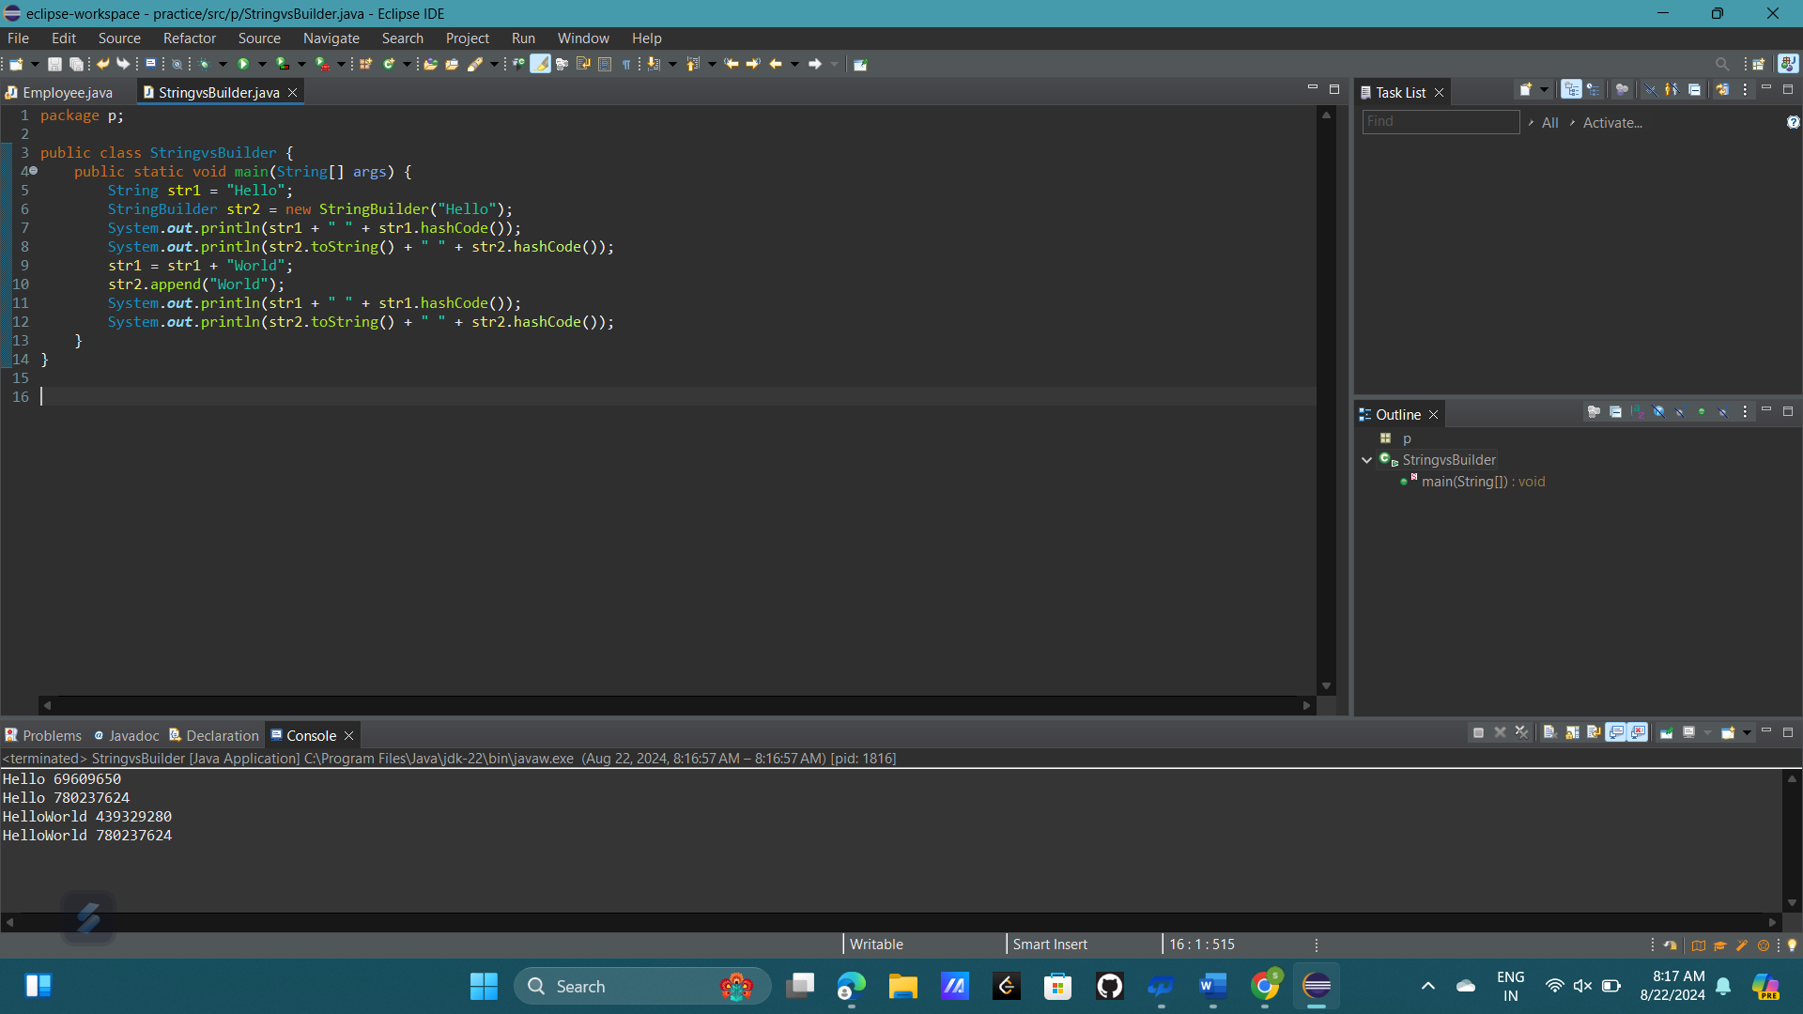

6.

public String reverseWithBuilder(String str) {

return new StringBuilder(str).reverse().toString();

}